AP Physics

Practice Problems – Standing Sound Waves - Resonance

Directions: Solve the following on a separate sheet of paper. State the given, find and solution for each problem.

4. A tube of air is open at only at one end and has a length of 1.5 m. This tube sustains a standing wave at its third harmonic. Draw a diagram of the wave. Label the nodes and antinodes. What is the distance from one node to the next? What is this distance in terms of wavelengths? Ans: 0.6 m, ½ λ

5. A drainage pipe running under a freeway is 30.0 m long. Both ends of the pipe are open, and wind blowing across one end causes the air inside to vibrate.

a. Draw a diagram of the fundamental frequency of a pipe open at both ends.

b. If the speed of sound on a particular day is 340 m/s, what will be the fundamental frequency of air vibration in this pipe? Ans: 5.67 Hz

c. Explain what will happen to the speed of sound later in the afternoon as the air begins to cool? Ans: decreases (why)

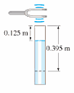

6. A tuning fork is set into vibration above a vertical open tube filled with water. The water level is allowed to drop slowly. As it does so, the air in the tube above the water is heard to resonate with the tuning fork when the distance from the tube opening to the water level is 0.125 m and again at 0.395 m. Speed of sound in air is 343 m/s. Speed of sound in water is 1490 m/s

a. How does the difference in the two water levels relate to the wavelength of the sound waves?

b. Determine the wavelength of the sound waves produced by the tuning fork Ans: 0.54 m.

c. What is the frequency of the tuning fork? Speed of sound in air is 343 m/s Ans: 635.19 Hz

d. What is the wavelength of the sound waves produced by this tuning fork in the water. Ans: 2.35 m

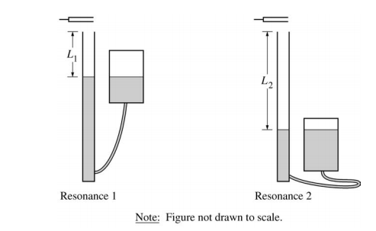FRQ Practice

A vibrating tuning fork is held above a column of air, as shown in the diagrams right. The reservoir is raised and lowered to change the water level, and thus the length of the column of air. The shortest length of air column that produces a resonance is L1 = 0.25 m, and the next resonance is heard when the air column is L2 = 0.80 m long. The speed of sound in air at 20o C is 343 m/s and the speed in water is 1490 m/s.

(a) Calculate the wavelength of the standing sound wave produced by this tuning fork Ans: 1.1 m

(b) Calculate the frequency of the tuning fork that produces the standing wave, assuming the air is at 20oC.

Ans: 312 Hz

(c) Calculate the wavelength of the sound waves produced by this tuning fork in the water. Ans: 4.8 m

(d) The water level is lowered again until a third resonance is heard. Calculate the length L3 of the air column that produces this third resonance. Ans: 1.35 m

(e) The student performing this experiment determines that the temperature of the room is actually slightly higher than 20oC. Is the calculation of the frequency in part (b) too high, too low, or still correct?

__________ too high ___________too low ________still correct

Justify your answer.